**SPRINT 4 DELIVERABLES**

1. **We have integrated our flask application with IBM cloud services.**

**1.1. We have created 3 resources in Object Storage, IBM Watson Studio and IBM Watson Machine Learning.**

**[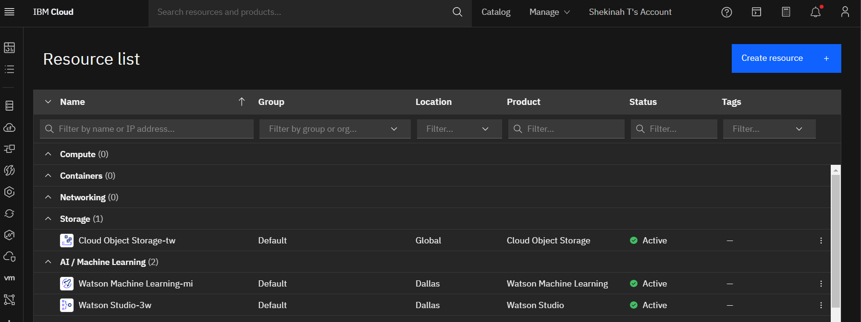](https://user-images.githubusercontent.com/64459672/201297285-7e3196d9-36c0-4614-aaab-2d307f6ac3f3.png)**

**1.2. We have trained our model and deployed our model in IBM Watson Studion's [Jupyter Notebook](https://github.com/IBM-EPBL/IBM-Project-14297-1659548839/blob/main/project%20development/sprint%204/Phishing_Website_Detection_IBM.ipynb).**

**[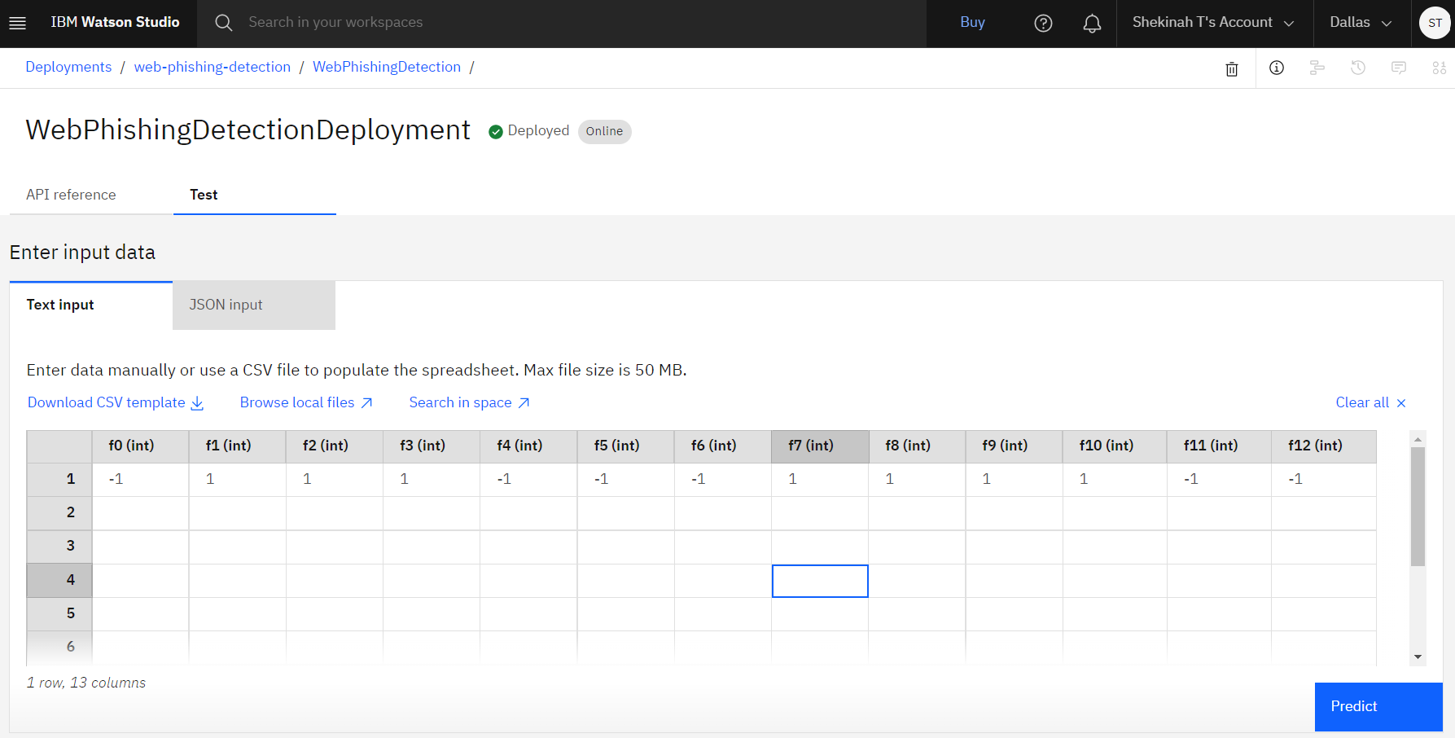](https://user-images.githubusercontent.com/64459672/201297403-c85ade01-765e-41aa-8374-d20cc3357de6.png)**

**[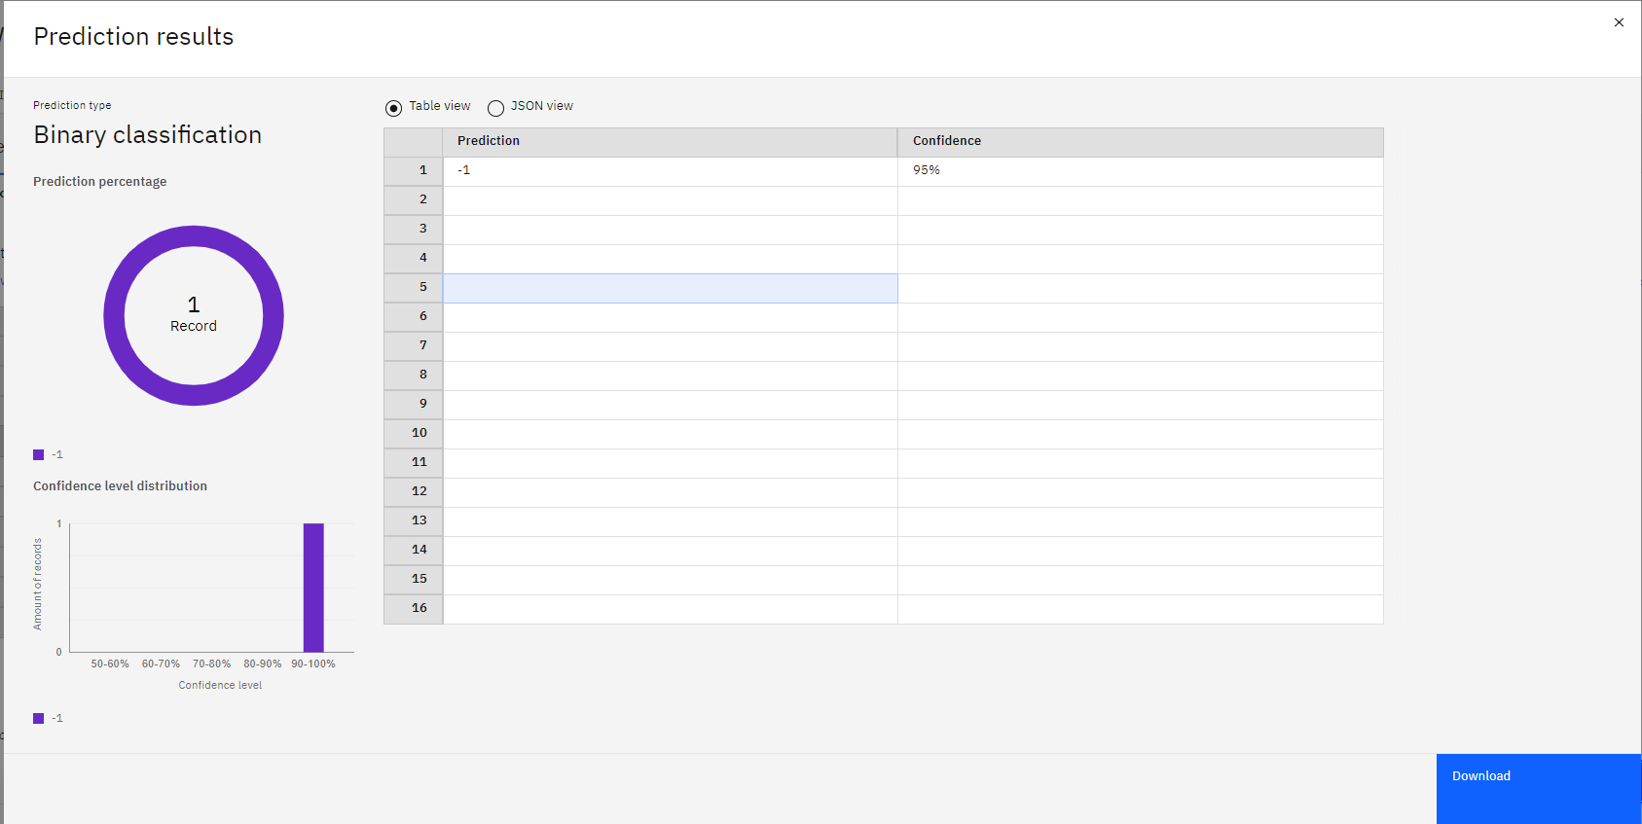](https://user-images.githubusercontent.com/64459672/201297420-eab0e2ad-4bc0-4d8c-b488-11bbd0939e72.png)**

**1.3. We have integrated it with our**[**flask application**](https://github.com/IBM-EPBL/IBM-Project-14297-1659548839/blob/main/project%20development/sprint%204/app.py)**to get scoring response.**

**[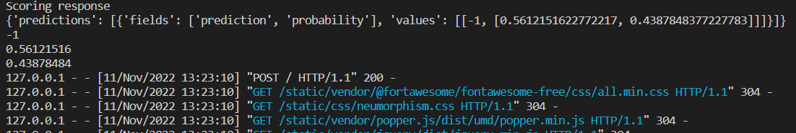](https://user-images.githubusercontent.com/64459672/201297320-f5150df0-0eb1-4527-98ee-e8012a6be85e.png)**

1. **Sample outputs:**

**[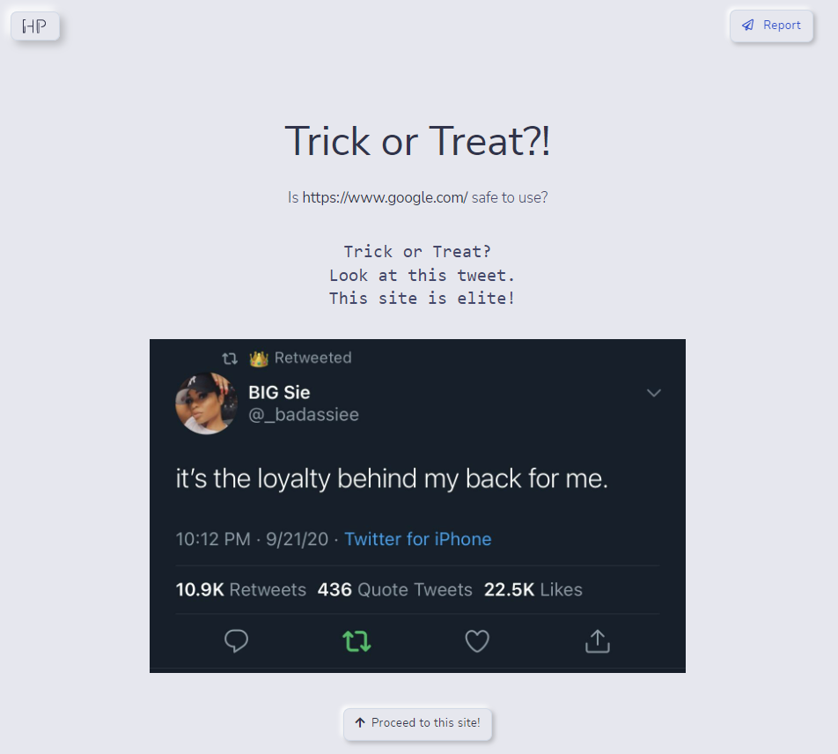](https://user-images.githubusercontent.com/64459672/201297479-2a5f85c9-96c4-4b15-81dd-3da391813527.png)**

**[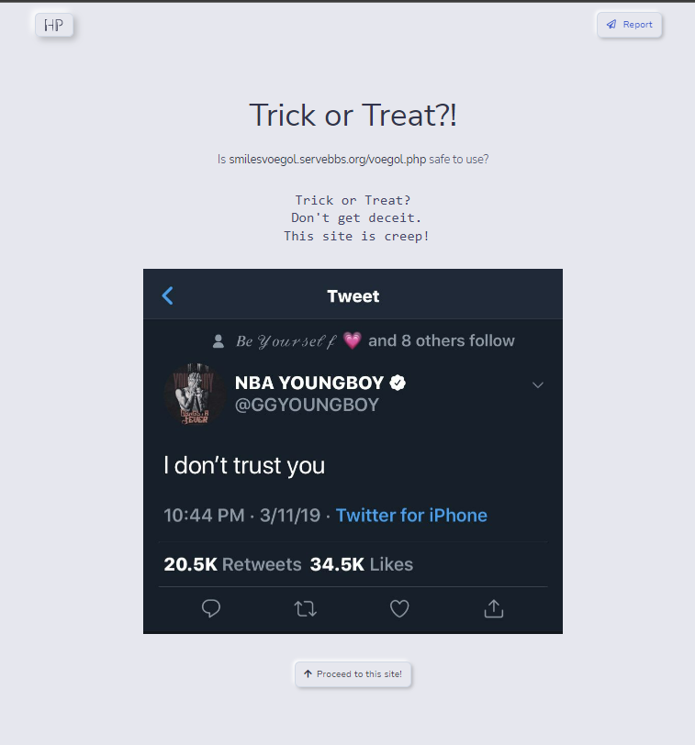](https://user-images.githubusercontent.com/64459672/201297516-3e5ac5ba-5bb3-40ae-8df1-45e7e01899c5.png)**